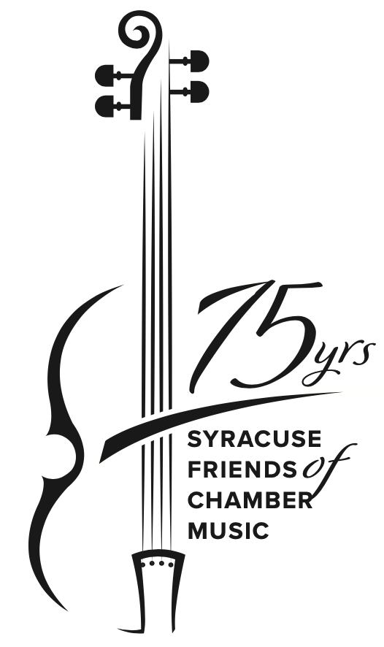
Table Reservation Form

Syracuse Friends of Chamber Music
75th Anniversary Celebration Dinner
September 27, 2024
Historic Grand Ballroom at the Marriott Syracuse Downtown

6:00 pm Hors d’oeuvres with open bar
7:00 pm The Juilliard String Quartet in concert
8:00 pm Dinner

Join us for Dinner with the Juilliard!
Use this form to purchase a table of eight tickets to the SFCM 75th Anniversary Celebration Dinner. If you wish to purchase individual tickets, please use the Individual Ticket Reservation Form.

Contact person name:_________________________________________ Phone: ____________________

Email address: __________________________________________________________________________

Table tickets
You can reserve a full table for eight with an $800 Table ticket.

Table ticket ($800) Amount enclosed: $__________

Mail this completed form with a check payable to SFCM 75th Anniversary Dinner to:
SFCM (Attn: 75th Anniversary Dinner)
P.O. Box 215
Dewitt, NY 13214

Tickets are non-refundable, but may be transferred. Please contact us as soon as possible (sfcm00@gmail.com) if you wish to make any substitutions.

We don’t expect you to know exactly who will sit at your table now, but we need their names and entrée choices by August 15, 2024. Please fill out the attached Table Information Form (also available for download on SyrFCM.org (celebration dinner page) or from sfcm00@gmail.com) and return it by August 15 to:
SFCM (Attn: 75th Anniversary Dinner)
P.O. Box 215
Dewitt, NY 13214

Thank you! We look forward to celebrating with you on September 27.

